**HTML – 5**

1. **What are the new tags added in HTML5?**

There are several tags added in HTML like

<audio>, <canvas>, <command>, <datalist>, <details>,<nav>,<video>

1. **How to embed audio and video in a webpage?**

The HTML5 <audio> and <video> tags make it simple to add mediato a website. You need to set srs attribute to identify the media source and include a controls attribute

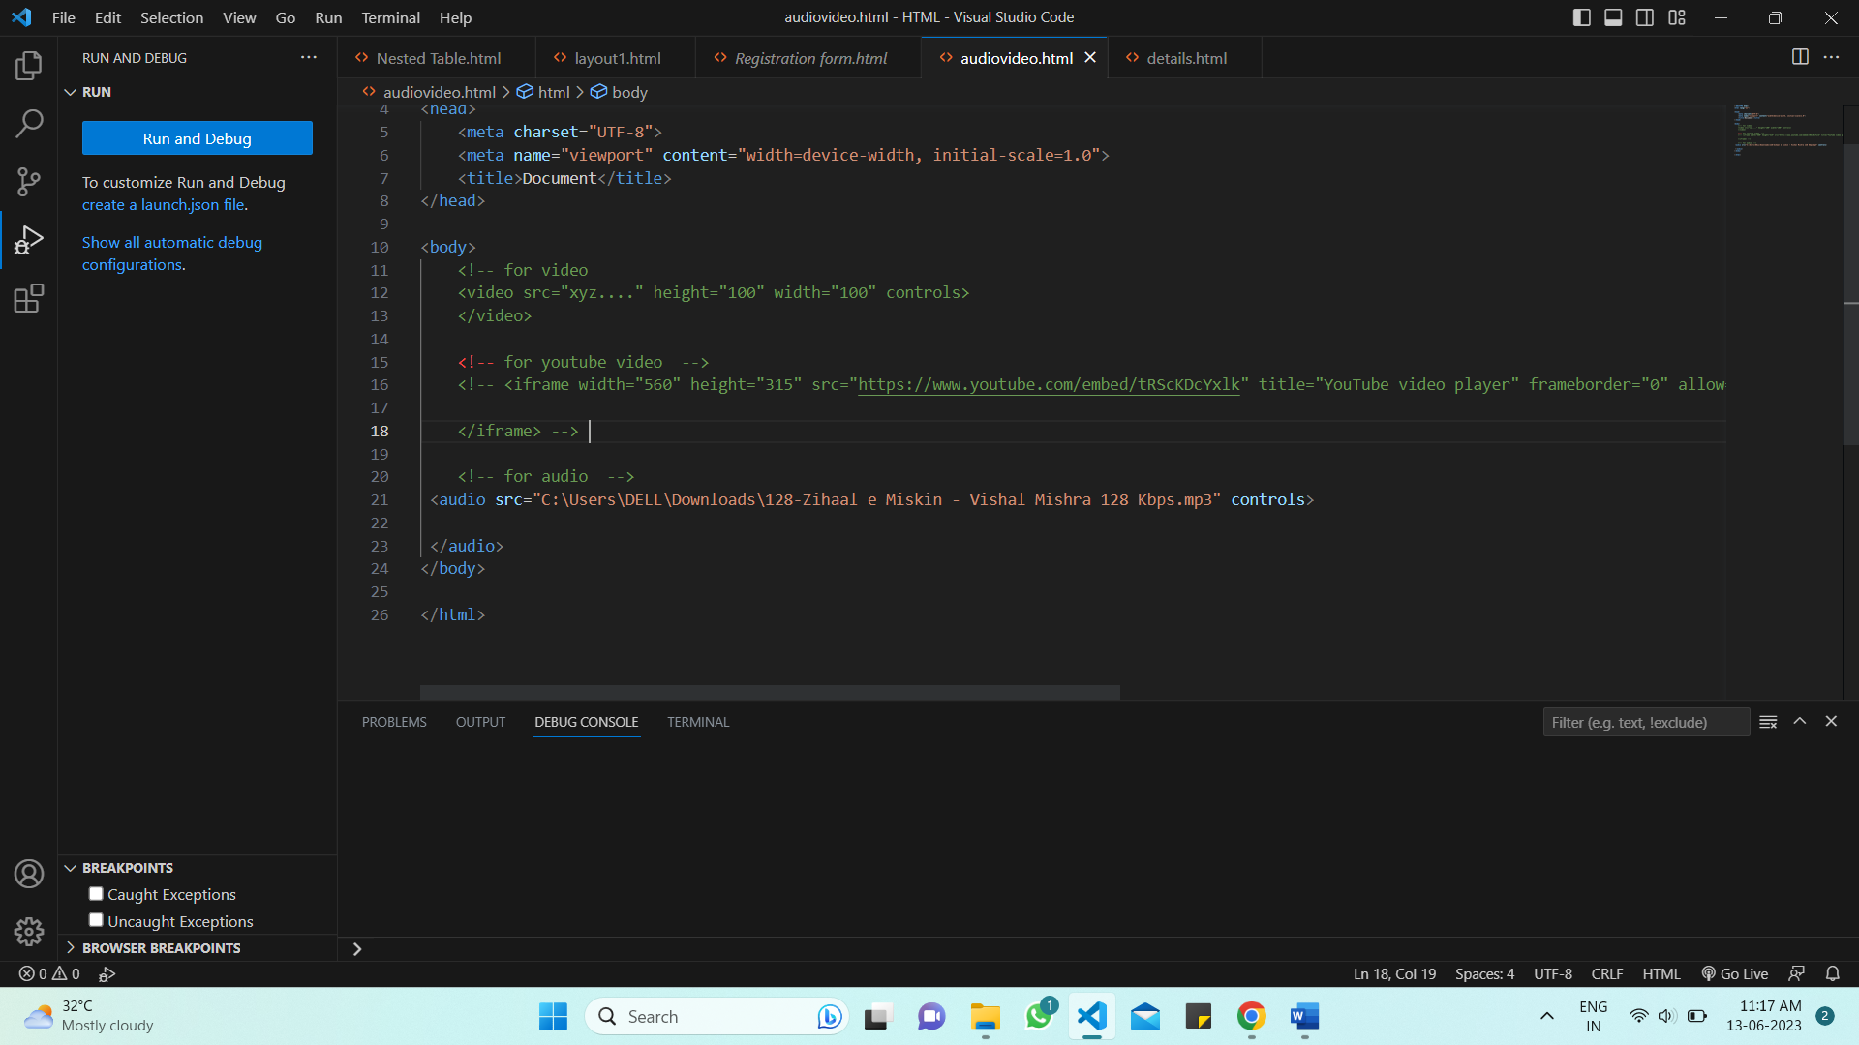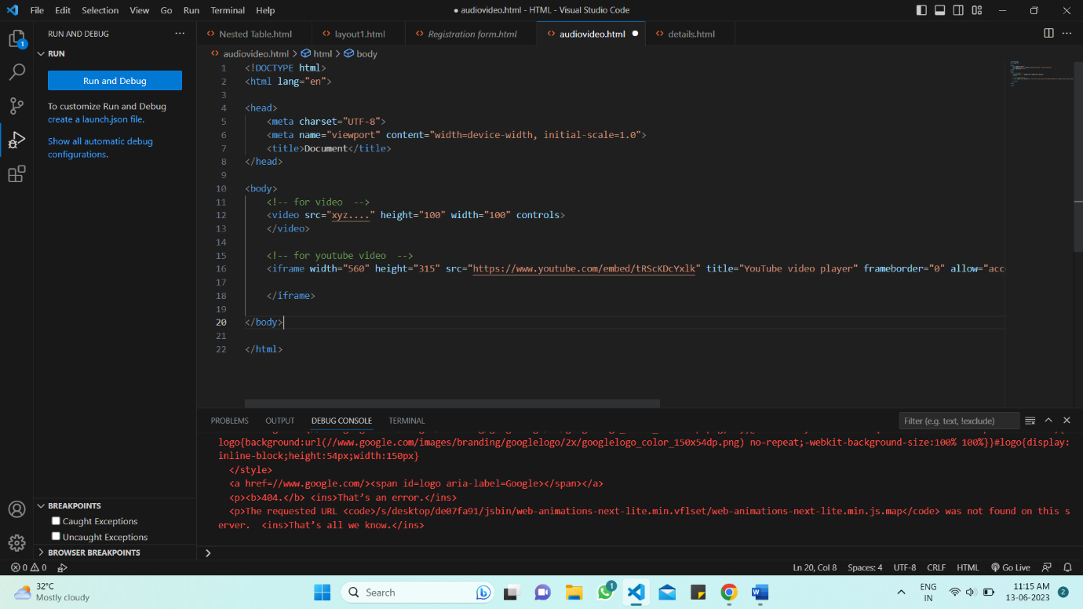

1. **Semantic elements in HTML5?**

Semantic elements are :

<header>, <footer>, <article>, <mark>, <nav>, <summary>